How to Confirm Your Attendance, Enroll in the Monthly Payment Plan and Make Your Initial Payment

- Log-in to your myRedDragon account
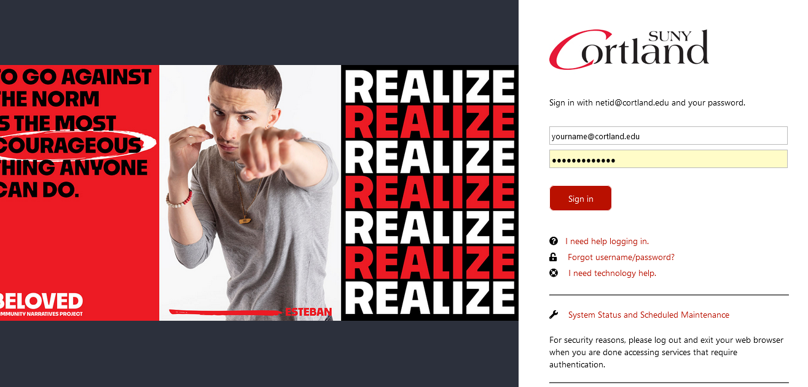

- Select the Student tab (your home page may view slightly different)
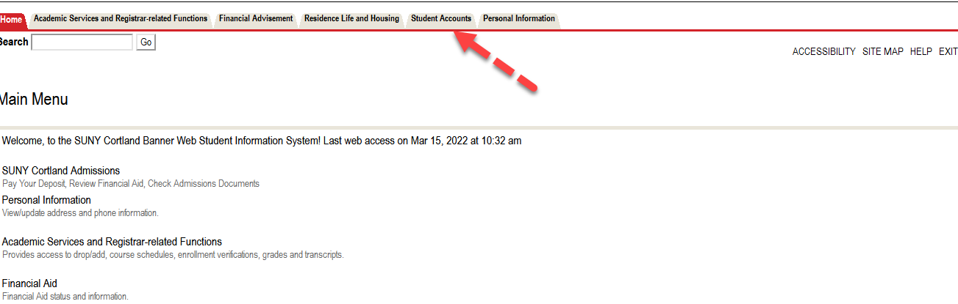

- Select Access Online Account
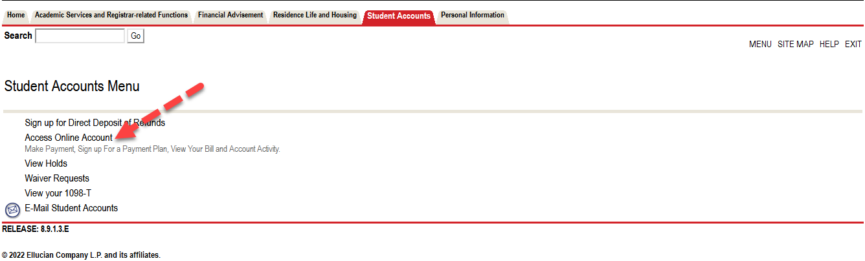

- Select term to confirm attendance
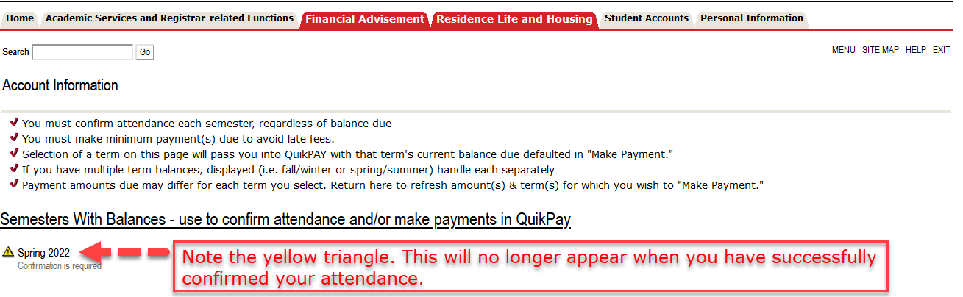

- Review your account summary and select “Accept/Pay or Decline.” All changes made to your student account will appear here in real time.
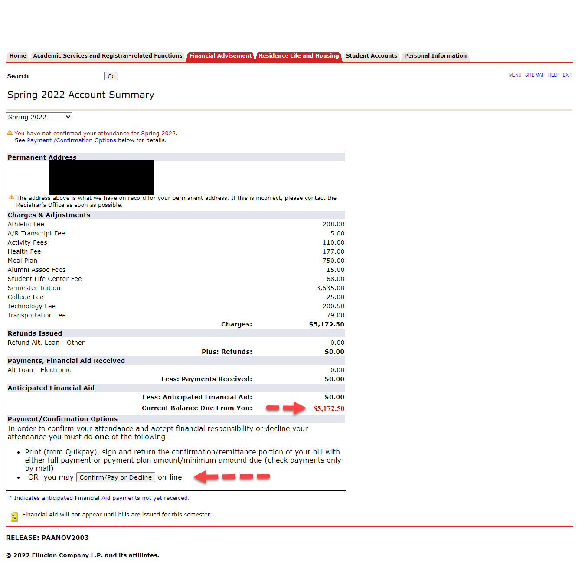

- Review verbiage, select “Accept” then “Continue” near the bottom of the page.
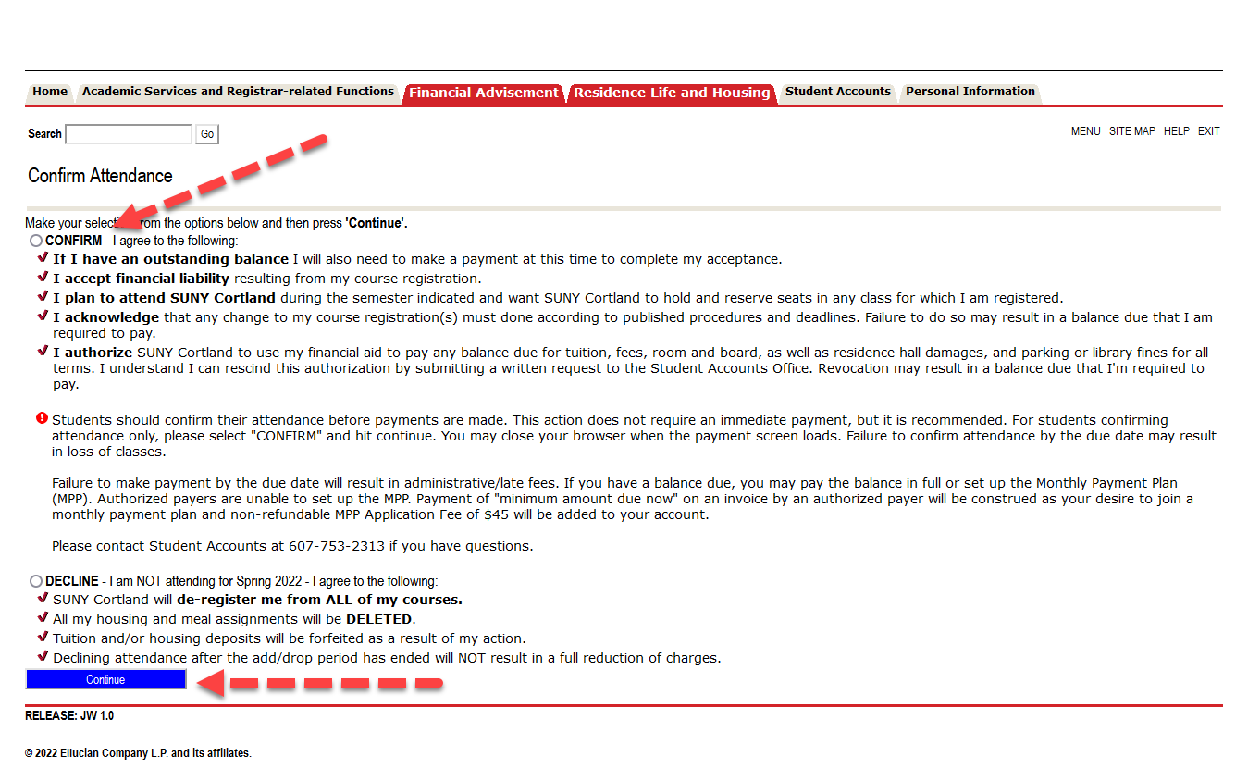
- Select “Start A Monthly Payment Plan”
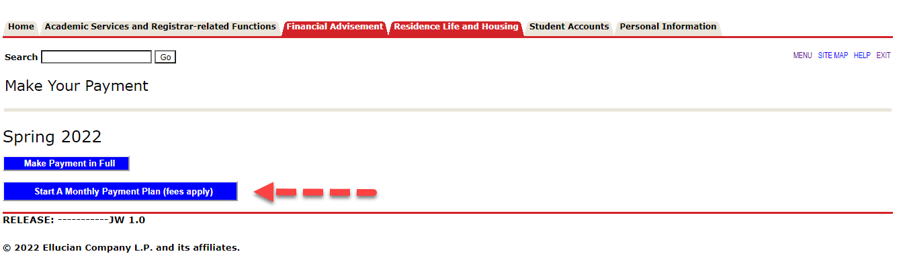

- Review the terms and conditions for the monthly payment plan. Select “I agree to all MPP terms” and then click on “Start Monthly Payment Plan.”
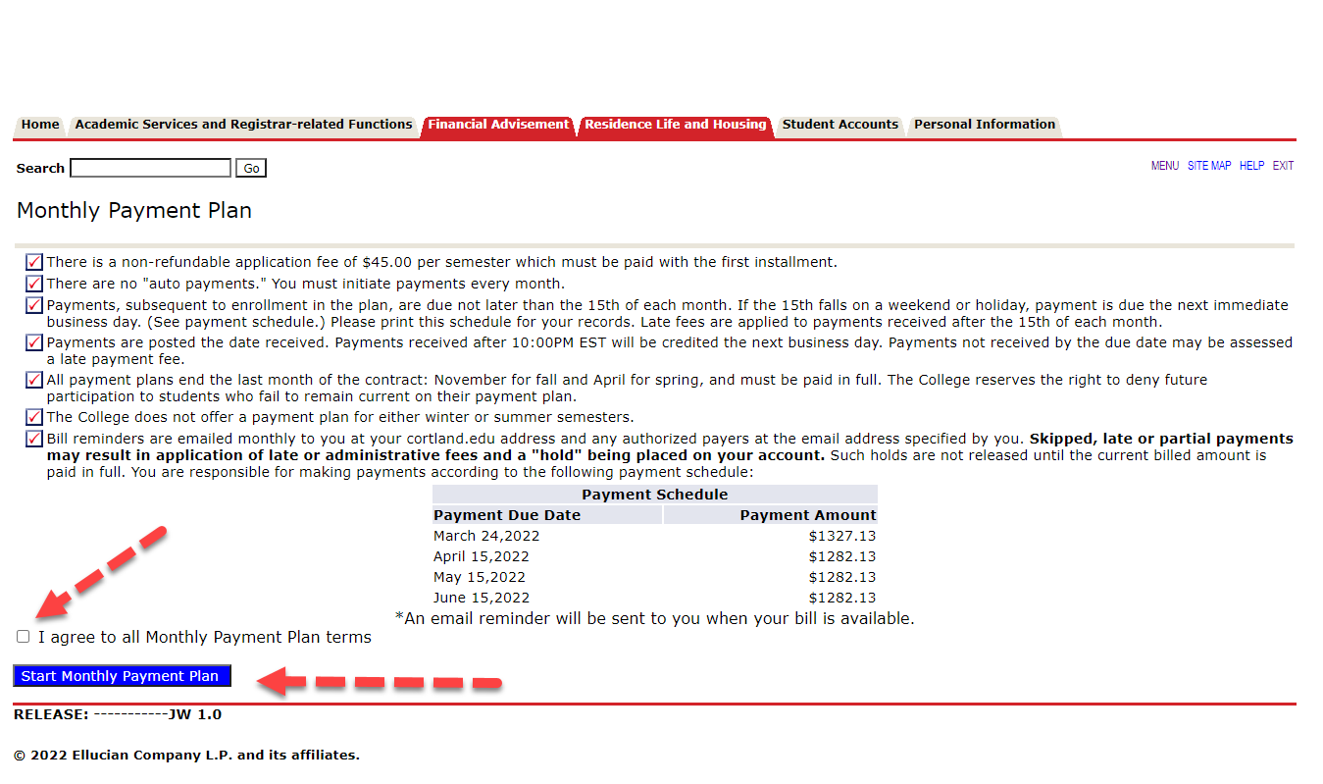
- Review the payment schedule and print a copy for your records. Please note that these monthly payments are NOT automatically charged to your payment source and will need to be initiated monthly. Select “Make Payment.”
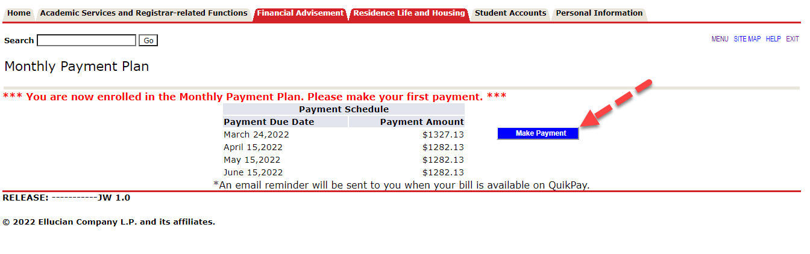

10. You will now be placed in our 3rd party billing/payment vendor’s site (QuickPay) to complete your payment. From the menu on the left, select “View & Pay Accounts.”
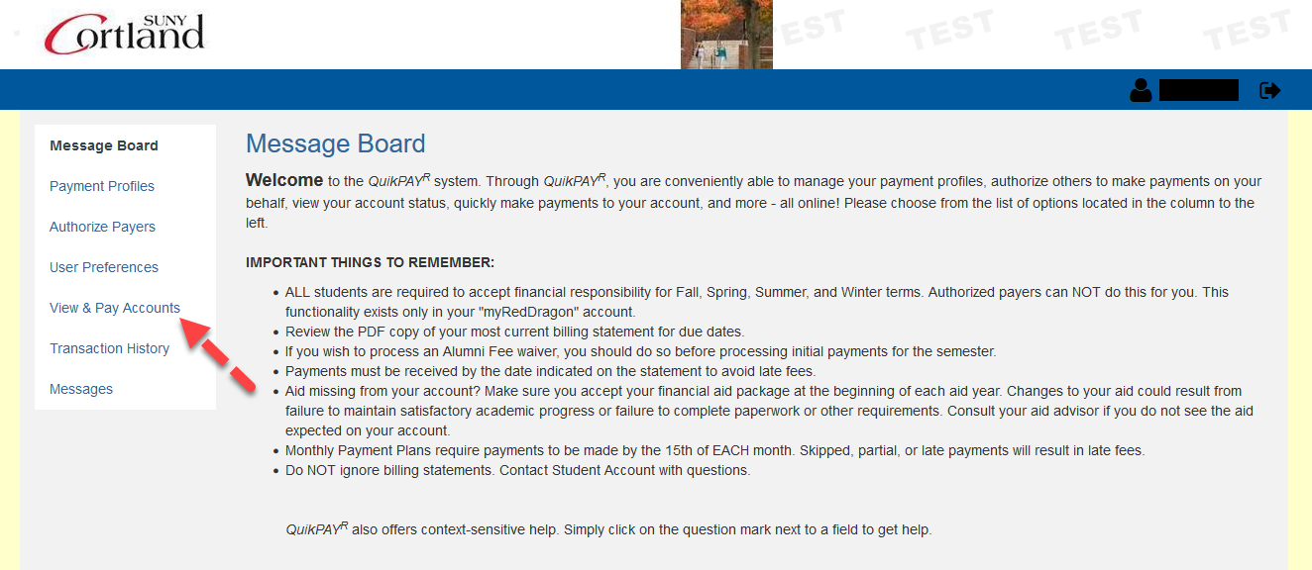
11. Select “Pay Other Amount” and enter your monthly payment amount which should be the amount due from this page if you are current on the plan. Select “Next- Payment Method”
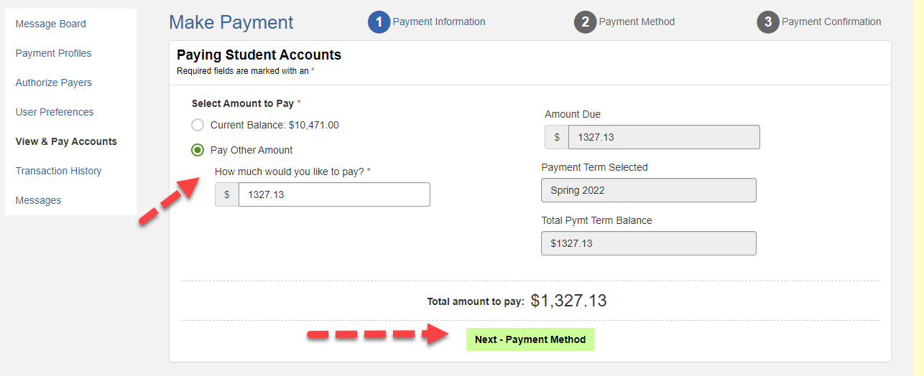
Once you click payment method, simply continue to complete your online payment by entering your credit card information or by using a previously saved payment source.

